Project Portfolio Management
Table of Contents
Introduction 3
What is PPM Software? 4
How PPM Software helps in management? 5
PPM Software in Market 6
References 6

Project Portfolio Management

Introduction
Assume you are a company owner multi-national company ABC Inc. One of your client asks you could you be able to develop my application within two months with a particular resources. As a company owner you will be thinking,
- Will my team be able to develop within time?
- Whom should I ask?
- Should I call all members?
You haven’t got much time. Clock is ticking...
What if you are able to see all resources, all works, all schedules, whether very important task is going on. Yes, we have got a tool that provides a sleek interface for you to monitor your whole company. You just need to visit the comprehensive dashboard that comes with this tool. You will get all the information that you need to say confident Yes or humble Sorry to your customer.
After saying that confident Yes, it’s three weeks. Your customer keeps on calling you what the progress of his works. Assume you got 1000 such clients. You will be thinking whether I had 48 hour a day. What if there is a tool to provide limited access to customer to take a look into his work?
Yes, there is a single tool for doing all these tasks in one place. It is called the Project Portfolio Management tool. It provides a sleek dashboard for both you and your customers while retaining abstraction required and integrity. Project Portfolio Management (PPM) helps to fill the gap between the dispersed data and people who need it and helps t produce granular reports.
Your company grows day by day. One day your company got selected to do most prestigious project. You need a to assign a good team. You have many constraints,
- Should not make worker work overtime.
- Other works in your company should go in parallel. So you cannot take all the best workers from all the projects that they are working on.
For making this possible you might need some additional information like
- How much progress one worker has done in respective projects?
- How efficient is he in doing his work?
- When does he complete?
- So on …
PPM proactively allocates and improves execution process of all projects in company’s portfolio. It enables us to focus on time tracking, capacity, demand and looking ahead and enables us to take better decision. Also provides information on health and status of proposed projects, which tells whether the project is running on-time or more care is needed.
Planning is the foundation of anything. In case of project development PPM helps to plan ahead by focusing on
- Demand Planning: Quantify your true resources requirement for planned projects.
- Capacity Planning: What we can achieve with projects we have.
- What-if scenario planning: Forward looking resources scenario planning for optimizing resources by portfolio projects, roles and individuals.
- Time Tracking: Promotes accountability and improve performance by knowing who is working on what and enables them to work more efficiently by giving them visibility.
- Project Status & Health: On-time and On-budget delivery.
As you are owner of the multi-national company you cannot handle the thousands of clients and their project. There will be a dedicated team working for planning, scheduling and monitoring of all works proposed by company. In this case you many not share the admin access to the members, all the operations involved in project management can be shared, distributed among different users based on their designation. PPM provides these features with ease.

What is PPM Software?
Project Portfolio Management Software is a tool that provide broad set of functionalities to plan, execute and control your portfolio and project management process. It provides a birds eye view over all the projects and operations. Helps us to standardize the project management strategy.
Data comes from different sources, one of them is the organization. One of the problem with organization data is its dispersed and hence making it not useful for analytics. PPM tool helps to collect all the dispersed data related to the project management. It provides clear metrics on
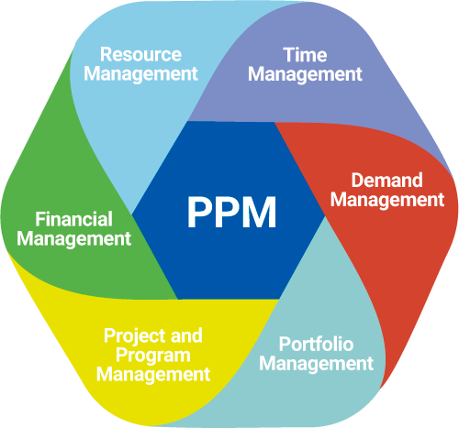
- Health and Status
- Tasks
- Workload
- Time
- Cost
- Progress

It also helps to display the project road-map on a Gantt chart and hence increasing the transparency and visibility of your organization.
77% of companies those who have used healthy PPM in there organization have anticipated achieving their 5 year revenue grown and goals.
Main goal of using PPM is to optimize the resource mix for both short term and long term. Thus increasing the performance, productivity, high level user adoption and satisfaction.

A good PPM software must provide

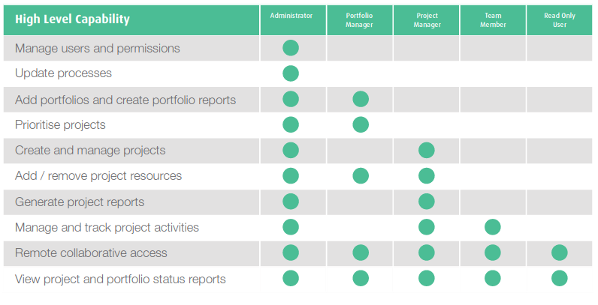
How PPM Software helps in management?
- Portfolio Management:
Addresses your organization's need for strategic and operational portfolio management. The application enables you to better control and innovate projects, processes, products, and services across their life cycles. It integrates information from existing project management, human resources, and financial systems to provide an overview of the project portfolio and resource availability.
- Resource Management:
Resource Management provides a planning tool for you to optimize your human resource deployment. It focuses on using your employees efficiently and assigning them to projects or orders based on demand, qualifications, and availability.
- Project Management:
Helps you manage project operations throughout the entire company enabling strong project management functionality including project planning and execution as well as project accounting. It supports structuring, scheduling, and visualization, and operative planning and execution.
- Analytics & Integration
Analytics and Integration: Flexible dashboards and sophisticated analytics drawn from disparate systems enable continuous monitoring of your portfolio's performance and your projects. PPM systems provides out-of-the-box transparency into project-cost actual data, forecasts, baselines, and other KPIs across your entire portfolio.

PPM Software in Market
(Will add details later)
- Microsoft Project and PPM
- SAP PPM
- Jira
- VersionOne
- Eclipse
- Clarity PPM
- PlanView
- Workflow
- etc…

References
- Bubble PPM - https://bubblegroup.com/ppm-growing-companies-portfolio-project-management-software/
- SAP PPM - https://www.edstechnologies.com/pdf/Product-Brochure/SAP%20Portfolio%20and%20Project%20Management.pdf
- PlanView PPM - https://www.planview.com/products-solutions/products/ppm-pro/project-portfolio-management/
- PAT Research - https://www.predictiveanalyticstoday.com/top-project-portfolio-management-ppm-software/
- Eclipse PPM - https://uplandsoftware.com/eclipseppm/product/features/
- Project Manager - https://www.projectmanager.com/software/project-portfolio-management
- SoftExpert (Images) - https://www.softexpert.com/solucao/project-portfolio-management-ppm/

